**NAME:** VARSHA CHAMARIA **SAP NO.:** 60004160013

**EXPERIMENT NO. 2**

**CODE:**

#include<stdio.h>

#include<conio.h>

#include<graphics.h>

#include<math.h>

void main()

{

int x0,y0,x1,y1,dx,dy,steps,p,i;

int gd=DETECT,gm;

initgraph(&gd,&gm," ");

// clrscr();

printf("Enter the first co ordinate");

scanf("%d%d",&x0,&y0);

printf("Enter the last co ordinate");

scanf("%d%d",&x1,&y1);

dx=x1-x0;

dy=y1-y0;

if(abs(dx)>abs(dy))

{

steps=abs(dx);

}

else

steps=abs(dy);

if(abs(dy)<abs(dx))

{

putpixel(x0,y0,RED);

p=2*abs(dy)-abs(dx);

for(i=0;i<=steps;i++)

{

if(p<0)

{

x0=x0+(dx/abs(dx));

y0=y0;

p=p+2*abs(dy);

}

else

{

y0=y0+(dy/abs(dy));

x0=x0+(dx/abs(dx));

p=p+2*abs(dy)-2*abs(dx);

}

/*if(i%2==0)

putpixel(x0,y0,RED);Dotted Line*/

/*if(i%5!=0)

putpixel(x0,y0,RED);Dashed Line*/

putpixel(x0,y0,RED);

}

}

else

{

putpixel(x0,y0,RED);

p=2*abs(dx)-abs(dy);

for(i=0;i<=steps;i++)

{

if(p<0)

{

y0=y0+(dy/abs(dy));

x0=x0;

p=p+2*abs(dx);

}

else

{

y0=y0+(dy/abs(dy));

x0=x0+(dx/abs(dx));

p=p+2*abs(dx)-2*abs(dy);

}

/*if(i%2==0)

putpixel(x0,y0,RED);Dotted Line*/

/*if(i%5!=0)

putpixel(x0,y0,RED);Dashed Line*/

putpixel(x0,y0,RED);

}

}

getch();

closegraph();

}

**OUTPUT:**

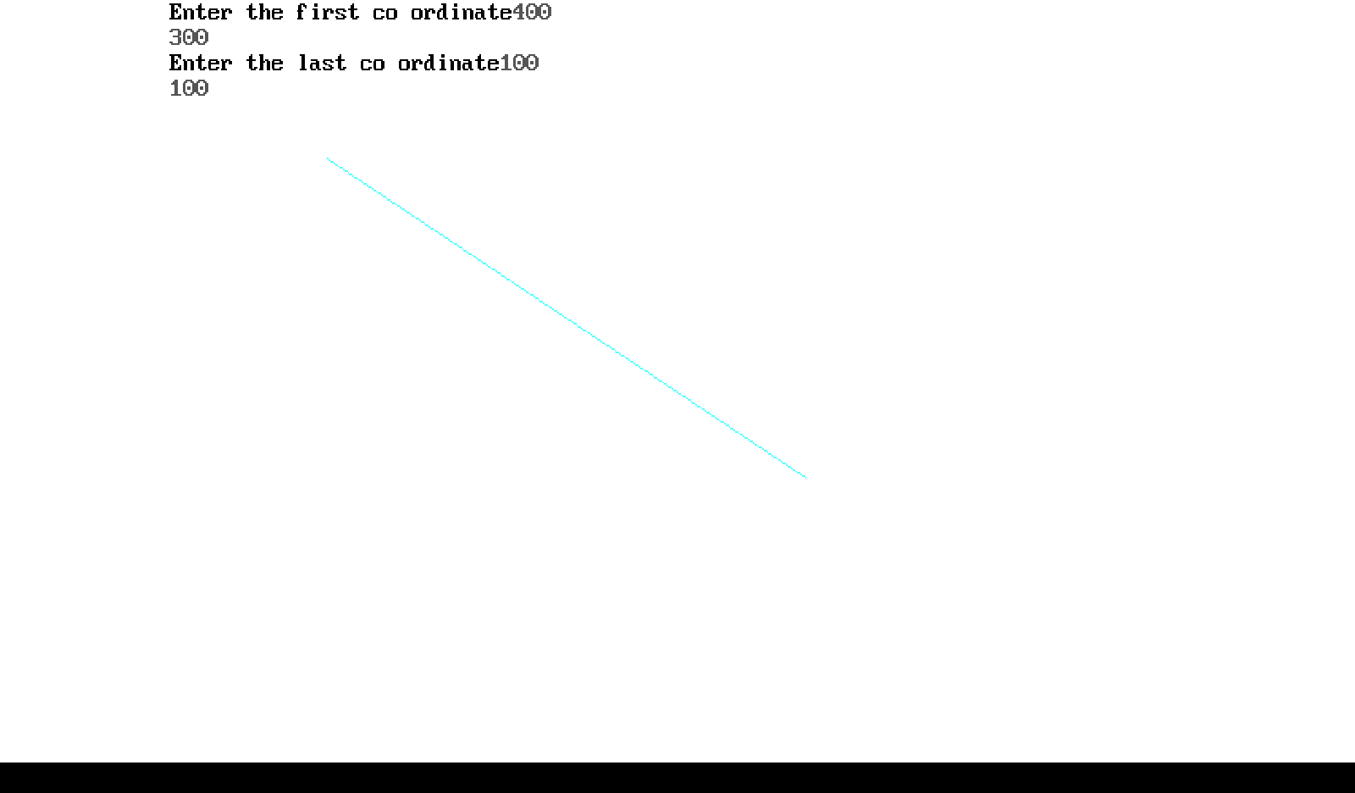

Dashed Line:

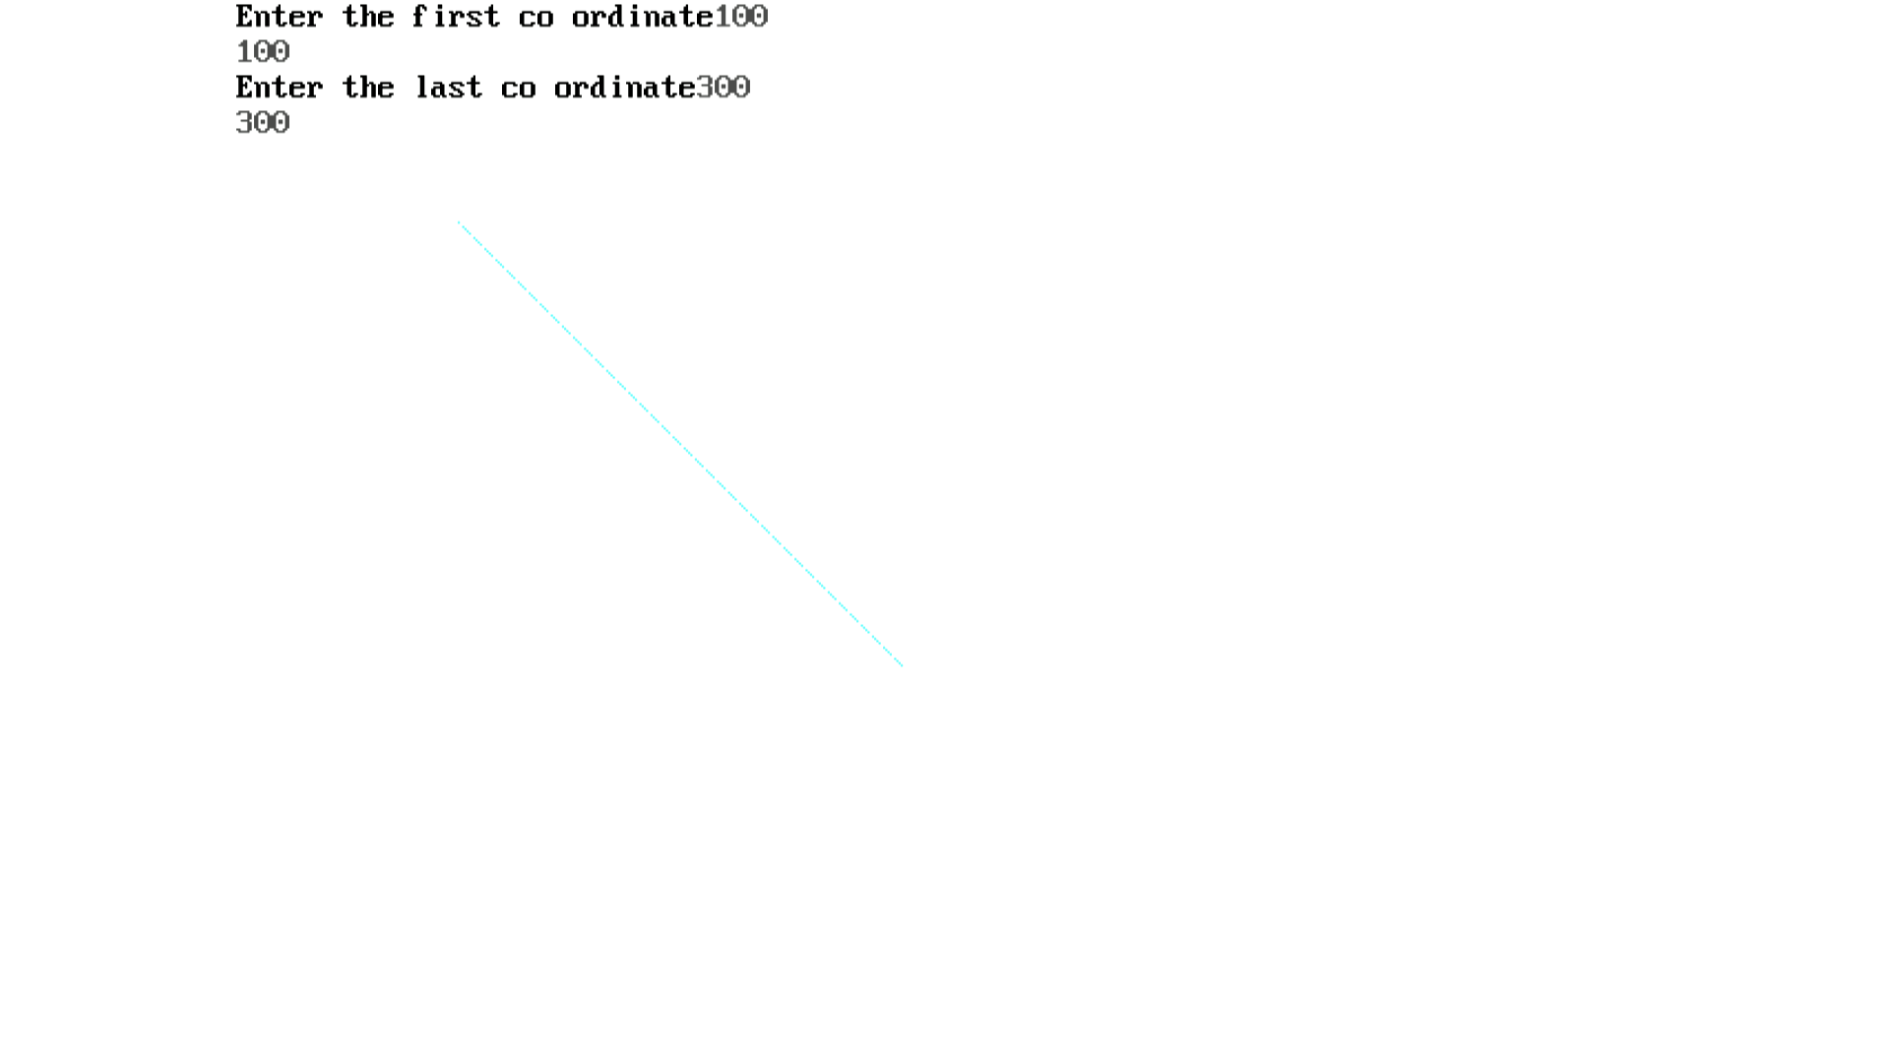

Dotted Line:

